Events Sample

Screenwriting is Filmmaking – an Introduction to Screenwriting and Script Development

With Brian Dunnigan

**Wednesday 30th October**

**6pm**

We are very excited to welcome Brian Dunnigan, former Head of Screenwriting at the London Film School and an award-winning short filmmaker and director, to Ripley and Lambert to give a talk and participate in a Q&A session about screenwriting and script development. He will also be signing copies of his new book, Screenwriting is Filmmaking, which is available to buy in the shop now.

Come listen to the experts!

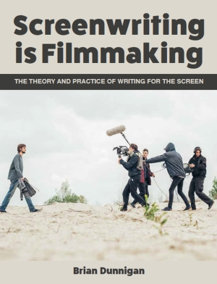Tickets are free of charge, please email [info@ripleyandlambert.co.uk](mailto:info@ripleyandlambert.co.uk) to reserve a space in advance.